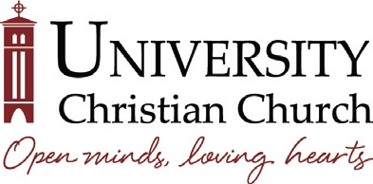

December 18, 2018 | 6:30pm • Room 150
Cathy Taylor, Chair

Board of Stewards Agenda

Welcome and Call to Order Cathy Taylor
Opening Prayer Kate Williams Listening to UCC Members

Updates and Reports
- Annual Giving Campaign Chad Cline
- Church & The Arts Ministry Division Jim Smith
- Outreach Ministry Division Ken Hubbell
- Women’s Ministry Division Gay McKeever
- Building & Grounds Report Melanie Towle*
- Endowment Report Kristi Hoban
- Finance Report Mark Alland
- Personnel Report Brenda Cline*
- Report from Deacons Matthew Smid
- Report from Elders Sandra Soria
- High Functioning Board Education with Todd Adams Recap Lindsay Klatzkin
- Senior Minister’s Report Rev. Dr. Russ Peterman

Action Items
- Approval of November Board Meeting Minutes Art Busbey
- Assignments for Calls to New Members Lindsay Klatzkin
- Board Retreat and Goal Setting Cathy Taylor
Executive Session
Talking Points
Closing Prayer
Adjournment
Next Board of Stewards Meeting: Tuesday, January 22, 2019 | 6:30pm • Room 150
The Board appreciates the presence of UCC members as visitors to its meetings. If a visitor wishes to speak to the Board, you are asked to sign in and limit your remark or question to three minutes. If a member desires action on a matter brought before the Board, the matter must be submitted to Betsy Ferguson at least two weeks before the scheduled Board meeting, including a summary of the facts and a draft motion.
*Or Assigns

